

A Report On
Special Project-1
Submitted by
Tarun Ajendla and J. Pawan Kalyan
20STUCHH010130,20STUCHH010020



FACULTY OF SCIENCE AND TECHNOLOGY
The ICFAI Foundation for Higher Education,
Hyderabad

October 2022

ABSTRACT

Software agents known as voice assistants can understand spoken language and respond with synthetic voices. The most well-known voice assistants are Google Assistant, Apple's Siri, Amazon's Alexa, Microsoft's Cortana, and Apple's Siri, and they are all built into smartphones or specific home speakers. Users can use voice commands to manage other common chores like email, to-do lists, and calendars in addition to asking their assistants questions, controlling home automation devices, and controlling media playback. This article will examine the fundamental principles and typical features of today's voice assistants.

Python is a good language for developers and scriptwriters, as we all know. We made the decision to use Python to create a Voice Assistant script. The user can change the assistant's question

TABLE OF CONTENTS
Chapter |  | Name | Page No.
01 |  | INTRODUCTION | 4
02 |  | LITERATURE REVIEW | 6
03 |  | Advantages | 8
04 |  | Disadvantages | 10
05 |  | Plan of work | 11
 | 5.1 | Modules needed | 13
06 |  | Code explanation | 14
07 |  | Conclusion | 20
08 |  | References | 20

INTRODUCTION
Modern society has made daily living smarter and more technologically connected. We are already familiar with voice assistants like Siri, Google, etc. It may now serve as a rudimentary medical prescriber, daily calendar reminder, note writer, calculator, and search tool using our voice help system. This project uses voice input, produces speech output, and displays text on the screen. Our voice assistant's primary goal is to educate individuals and provide quick, calculated results. The voice help receives voice input from our microphones (wired and Bluetooth) and turns it into computer-understandable English before providing the user with the necessary solutions and replies. This support makes a connection to the Internet to give users with results they have questioned. A natural language processing algorithm enables computer systems to communicate using many forms of natural human language.
This system is made to work effectively on desktop computers. The management of repetitive chores by the user and the provision of information from an internet source are two ways that personal assistant software increases user productivity.

The foundation of this project is the idea that there is enough freely accessible data and information online that may be used to create a virtual assistant with the ability to make wise decisions on common user tasks.

LITERATURE REVIEW

The voice assistant is often considered an inclusive and integrative enabler of many advanced technologies. It includes many additional features such as more privacy, security, accuracy and time consumption, magnification and effect.[1] considering the general study, the speech application is mainly used in three ways. 1. First, it commands the computers. 2. Second, enter the data into the computer. 3. Finally, this human communication and speech application can be divided into front end, voice recognition, end users and text file database.[2] Data is collected in the form of speech and stored as input for the next stage of processing, and the input audio is continuously processed to be converted to text using STT. [3] At the end of the text, speech refers to the ability of computers to read text aloud and convert written text into speech, and a TTS engine with dialects and special vocabularies available through a third party.
The simulation results show that the different branches of our proposed PARI services for speech recognition engine can work without internet connection and offline voice recognition. [5] And we explained the methods and focused on the best virtual assistants that allow several options. equipment and a few questions they had to ask all four IVAs.
Another article compares non-public support staff to recognize the design, architecture, and implementation of the framework (Ricky and Gulo, 2015). Costa, Novais and Julian (2018) are
finally looking at cognitive assistants, a subset of IPAs that is primarily based totally on all-spherical platforms.The article lists new projects, summarizes the state-of-the-art issues, and discusses how generation supports elderly people with disabilities or continual conditions. Nobody proposed a systematic literature The review identifies several key areas
of Voice Assistant research by analyzing all the documents found in this study. Bugden and Brereton (2006) state that systematic reviews are a way of identifying, evaluating and interpreting all available research related to a particular research topic or area. This type of workis important in many areas such as artificial intelligence, expert systems, cognitive and conversational agents, as it identifies key applications, technology-based solutions, software architectures, challenges and open questions, and opportunities for Voice Assistants.

Q- What are the areas that provide opportunities to Voice Assistant applications?

Based on their offer, we identified opportunities for Voice Assistant applications. Thus, articles classified in the field of education would offer second language learners a focus on games andsports (Kobayashi, Tanio and Sassano, 2015), build a structure for audio games (Cicció and Quesada 2018) and outdoor play (Vora et al. , 201); and a bicycle. In this regard, they are supported by articles on sports (Todoorov et al., 2016; Zhu et al., 201). As predicted by the health industry, the most cited work focuses on maintaining and processing vital functions of consumers (Angelini et al., 2013; Santos et al., 2016) and recommending treatments (Allen et al., 2018; Silva). et al., 2017). The same is true in the fields of privacy and usability, where most of the work is focused on improving user experiences (Kiseleva et al., 2016b), understanding and explaining the use of Voice Assistants (Cowan et al., 2017 ; Graus et al., 2016b). al., 2016; Hsieh and Buehrer, 201; Porcheron, Fischer, & Sharples, 2017) and 2015; Nogueira et al., 2017). Infrastructure work focuses on auxiliary selection and discussion (Hauswald et al., 2016; 2015; Heredero, Penmetsa, Agrawal, & Shastri, 2013). There are several general studies focusing on voice assistants and raising understandable concerns (Bellegarda, 2013; 201; Moore, 2016) and new research proposed by assistants (Misra and Such, 2017; Vinothini et al., 2017).

ADVANTAGES

- Users can speak on the phone using the voice user interface without needing to hold it close to their ears. You only need to push a button to answer the call if it rings when you are in an uncomfortable situation, such as bathing or driving, and then you can talk to the caller hands-free.
- If you are familiar with how VUI devices operate, you can use one as an extra hand and time saver. You can ask Google Maps for directions while driving by speaking to it and letting it know where you want to go. You'll have a lower likelihood of getting lost as a result. It saves you from having to get out your phone and look up the route on the map.
- So that your personnel can be placed in better positions, it can take over a lot of the boring tasks associated with phone operation. Both incoming calls and SMS text messages can be handled by it. Additionally, it has the ability to forward your calls to another number. It can convert your spoken words into text that is typed in the page, so you can tell it to take down notes. It is the ideal solution for administrators who prefer to work primarily in front of computers rather than surrounded by notes on their desks.
- It can be a very useful tool for those who have disabilities. The VUI gadget can read emails, articles on websites, and documents aloud to people who are blind or visually challenged. It can turn audio-books and communications into text so that persons with hearing impairments can read them on a computer screen. Using their hands to interact with the products is challenging for people with disabilities. By incorporating technology into your product, you will be able to outsell rivals that produce less usable goods.
- Using a voice recognition technology can make it easier for persons who speak different languages to communicate. This is so that you can comprehend what is being said while it is being spoken in a foreign language because it has an integrated translation function. It can assist tourists in getting past a language barrier so they can

DISADVANTAGES
- Virtual assistants can handle smart home appliances, but they are pricey and not everyone can afford them. They use a lot of electricity as well. Therefore, you should anticipate paying a larger electricity cost if your home has a lot of smart home gadgets. You can't use them while the electricity is out.
- You risk becoming disengaged from the work at hand if you utilise a voice-activated virtual assistant. While giving instructions to the virtual assistant, you are simultaneously attempting to complete the task at hand and paying attention to the virtual assistant. When your focus is split, mistakes are more likely to occur. So be cautious to pause what you're doing before giving a virtual assistant directions.
- Your data may be recorded by the manufacturer if you use a VUI device. The Cambridge Analytica incident, for instance, raised concerns that Google Home and Amazon Alexa were listening in on people's private chats. People start to worry about how these firms will exploit their personal information as a result. Manufacturers are now attempting to provide consumers with improved privacy options so they may use the device in peace after becoming aware of the problem.

Plan of work
Analyzing the audio commands issued by the user through the microphone was the first step in the process. This could involve anything, such as obtaining information or managing computer files, etc. This study is based on reading the aforementioned material and putting its examples to the test. With the express purpose of discovering best practises and a deeper understanding of voice assistant, tests are made by programming in accordance with books and internet resources.

The difficulties don't end there, though. The software may not be able to understand you even after hundreds of hours of input because of other reasons. A speech recognition system might easily become confused by background noise. This is because it lacks the ability to tell the difference between your voice and the background noises it "hears," such as a dog barking or a helicopter buzzing overhead. Engineers must programme such capability into the apparatus; they gather data on these background noises and "teach" the apparatus to filter them out. Speech recognition algorithms may be sensitive to the way people instinctively adjust their voice pitch to compensate for noisy situations, which is another factor.

In speech recognition, audio is transformed into text. This is frequently employed by voice assistants like Siri, Alexa, and others. Python offers an API called SpeechRecognition that enables audio to text conversion for further processing. In this post, we'll examine how to use Python's SpeechRecognition API to transform lengthy or big audio recordings into text.

Modules Needed

- Subprocess: This module is used to retrieve information on system subprocesses that are utilised in a variety of commands, such as shutdown and sleep. Python already includes this module.
- Pyttsx3:- This module converts text to speech in a programme and operates in the background. Type the following command in the terminal to install this module.install pyttsx3 with pip
- Wikipedia:- We have utilised the Wikipedia module on GeeksforGeeks to retrieve information from Wikipedia or to do a Wikipedia search since, as we all know, Wikipedia is a fantastic repository of knowledge. Type the following command in the terminal to install this module.pip install wikipedia
- Speech Recognition: Since we are developing a voice assistant application, one of the most crucial components of this is that your assistant understands what you are trying to say or ask. Type the following command in the terminal to install this module. Pip install SpeechRecognition
- Web browser:Use a web browser to conduct a web search. Python already includes this module.
- Datetime:- Date and Time are used to showing Date and Time. This module comes built-in with Python.
- The most recent version of Riverbank Computing's GUI widget toolkit is PyQt5. Qt, one of the most effective and well-liked cross-platform GUI libraries, has a Python interface. The Python programming language and the Qt library are combined in PyQt5. You may use PyQt to build graphical applications with the help of this basic tutorial
- These are required modules for building an voice assistance
from PyQt5 import QtWidgets, QtGui,QtCore
from PyQt5.QtGui import QMovie
import sys
from PyQt5.QtWidgets import *
from PyQt5.QtCore import *
from PyQt5.QtGui import *
from PyQt5.uic import loadUiType
import pyttsx3
import speech_recognition as sr
import os
import time
import webbrowser
import datetime
import ctypes
import wikipedia
import subprocess

Code explaination
engine = pyttsx3.init('sapi5')
voices = engine.getProperty('voices')
engine.setProperty('voice',voices[0].id)
engine.setProperty('rate',180)
- You can change the voice Id to “0” for the Male voice while using assistant here we are using a Female voice for all text to speech .This code is used for getting engine voices built in your device
def speak(audio):
engine.say(audio)
engine.runAndWait()

def wish():
hour = int(datetime.datetime.now().hour)
if hour>=0 and hour <12:
speak("Good morning")
elif hour>=12 and hour<18:
speak("Good Afternoon")
else:
speak("Good night")
Def speak(audio) is used for assistant to speak
Def wish() is written so that the assistant wishes the user when its in use or opened.
def STT(self):
R = sr.Recognizer()
with sr.Microphone() as source:
print("Listening...........")
audio = R.listen(source)
try:
print("Recog......")
text = R.recognize_google(audio,language='en-in')
print(">> ",text)
except Exception:
speak("Sorry Speak Again")
return "None"
text = text.lower()
- This sccript is used for assistant to listen understand or recognize when the user gives a command

def JARVIS(self):
wish()
while True:
self.query = self.STT()
if 'good bye' in self.query:
sys.exit()
elif 'open google' in self.query:
webbrowser.open('www.google.co.in')
speak("opening google")
elif 'open youtube' in self.query:
webbrowser.open("www.youtube.com")
elif 'play music' in self.query:
speak("playing music from pc")
self.music_dir ="./music"
self.musics = os.listdir(self.music_dir)

elif 'the time' in self.query:
strTime = datetime.datetime.now().strftime("%H:%M:%S")
speak(f"the time is {strTime}")
print(strTime)

if 'wikipedia' in self.query:
speak('Searching wikipedia...')
self.query = self.query.replace("wikipedia", "")
results = wikipedia.summary(self.query, sentences=2)
speak("According to Wikipedia")
print(results)
speak(results)

elif "don't listen" in self.query or "stop listening" in self.query:
speak("for how much time you want to stop nothing from listening commands")
a = int(self.STT())
time.sleep(a)
print(a)

elif 'lock window' in self.query:
speak("locking the device")
ctypes.windll.user32.LockWorkStation()
- These are the different commands code, if user is given a command then it checks the command is there are not,if there it performs or says command not available

FROM_MAIN,_ = loadUiType(os.path.join(os.path.dirname(__file__),"./scifi.ui"))

class Main(QMainWindow,FROM_MAIN):
def __init__(self,parent=None):
super(Main,self).__init__(parent)
self.setupUi(self)
self.setFixedSize(1920,1080)
self.label_7 = QLabel
self.exitB.setStyleSheet("background-image:url(./lib/exit - Copy.png);\n"
"border:none;")
self.exitB.clicked.connect(self.close)
self.setWindowFlags(flags)
Dspeak = mainT()
self.label_7 = QMovie("./lib/gifloader.gif", QByteArray(), self)
self.label_7.setCacheMode(QMovie.CacheAll)
self.label_4.setMovie(self.label_7)
self.label_7.start()

self.ts = time.strftime("%A, %d %B")

Dspeak.start()
self.label.setPixmap(QPixmap("./lib/tuse.png"))
self.label_5.setText("<font size=8 color='white'>"+self.ts+"</font>")
self.label_5.setFont(QFont(QFont('Acens',8)))

app = QtWidgets.QApplication(sys.argv)
main = Main()
main.show()
exit(app.exec_())
- This is GUI code for the voice assistant

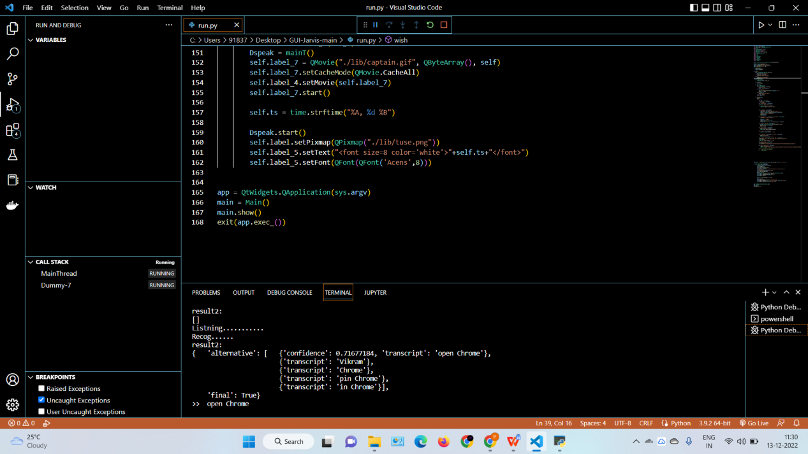

- Output in VS code while running
(It is taking command ‘opening chrome’)

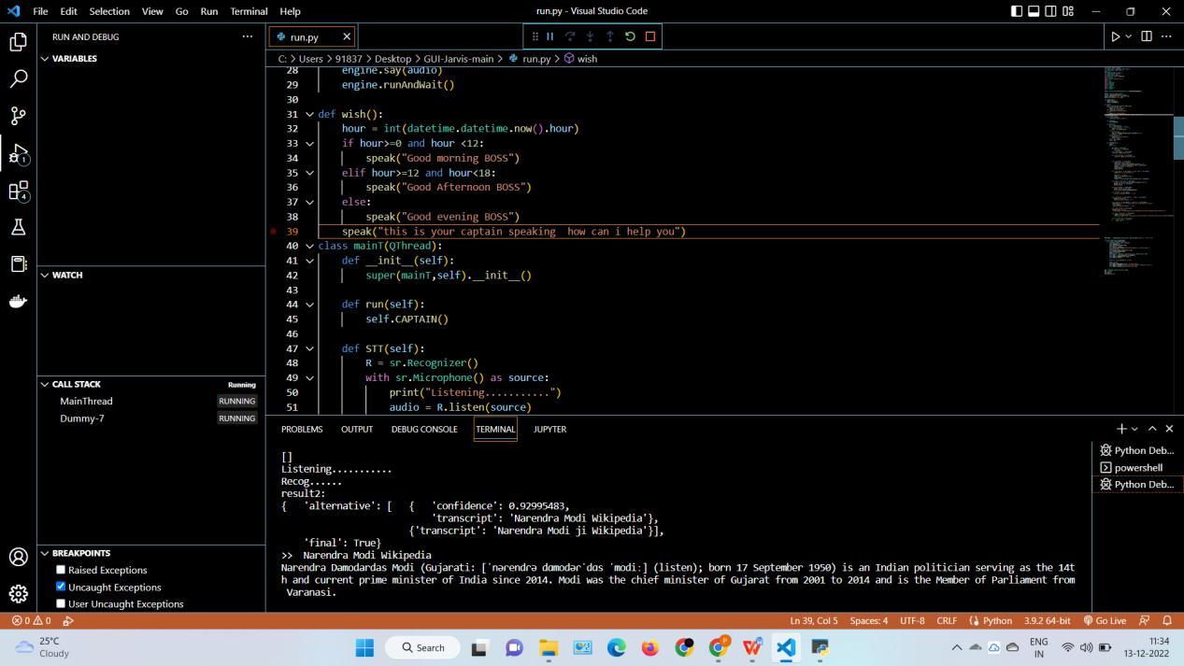

- Output in VS code while running Wikipedia
(It is opening our command ‘ Narendra Modi Wikipedia ‘)

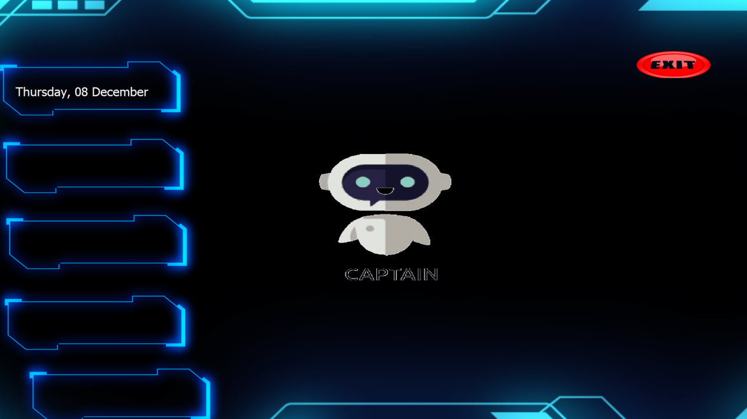
- This is our GUI

Conclusion

The Visual studio community has supported the project's use of open source software components, which can quickly accommodate any modifications. This project's modular design gives it greater flexibility and makes it simple to add new features without impairing existing system functionality.
It not only responds to human orders but also to questions posed by the user or words said by the user, such as opening operations and tasks. The voice assistant is introducing itself to the user in a way that makes them feel more at ease and allows them to engage with it freely. The programme should also get rid of any extra manual labour that is required for users to complete each job. The entire system relies on verbal input rather than visual data, and

References
https://www.geeksforgeeks.org

